Project Report

On

**Customize Shopping**

***Submitted By:***

**PARIMAL JETHVA (146250307512)**

**PREET BADIYANI (146250307503)**

**NIKHIL TANK (146250307058)**

***SEM-5***

**COMPUTER ENGINEERING**

***In***



**GOVERNMENT POLYTECHNIC**

**JAMNAGAR**

**Government Polytechnic, Jamnagar**

**Computer Engineering**

**2016**

**CERTIFICATE**

**Date:21/10/2016**

This is to certify that the dissertation entitled **“CUSTOMIZE SHOPPING”** has been carried out by **Parimal Jethva, Preet Badiyani and Nikhil Tank** under my guidance in fulfillment of the Diploma Engineering in Computer (5th Semester) of Gujarat Technological University, Ahmedabad –Government Polytechnic Jamnagar during the academic year 2016-17.

**Internal Guide Head of the Department**

R. M. Galolia K.M.SHAH

ACKNOWLEDGEMENT

Every work that one complete successful stands on the constant encouragement, goodwill and support of the people around. I hereby, avail this opportunity to express my heartfelt gratitude to a number of people who extended their valuable time, and cooperation in developing this project.

We would like to thank this opportunity to express our deep gratitude and sincere thanks to my respected internal guide  **R. M. Galolia** and external guide provide us with the all valuable guidance, encouragement, support and constructive criticism without which this project would not have been materialized.

Last but not least we would like to thanks our parents and a family member whose love and support has allowed us to achieve this goal.

With sincere regards,

Parimal Jethva

Preet Badiyani

Nikhil Tank

**ABSTRACT**

This project is a web based Customize shopping system for an existing shop. The project objective is to deliver the online Customize shopping application into Android platform.

This project is an attempt to provide the advantages of customize shopping to customers of a real shop with their choice. It helps buying the products in the shop anywhere through internet by using an android device. Thus the customer will get the service of customize shopping and home delivery from his favourite shop. This system can be implemented to any shop in the locality or to multinational branded shops having retail outlet chains.

If shops are providing an online portal where their customers can enjoy easy shopping from anywhere, the shops won’t be losing any more customers to the trending online shops such as flipcart or ebay. Since the application is available in the Smartphone it is easily accessible and always available.

INDEX

|  |  |  |
| --- | --- | --- |
| Sr. | TOPIC | Page No. |
| 1 | INTRODUCTION   * 1. Project Summary   2. Project overview   3. Project Scope   4. Study Of The System   1.4.1 MODULES  1.4.1.1 ADMIN  1.4.1.2 USER | 6 to 11 |
| 2 | SYSTEM ANALYSIS  2.1 Software Requirement Specification  2.2 Process Model  2.3 Feasibility Study | 12 to 21 |
| 3 | SYSTEM DESIGN  3.1 E-R Diagram  3.1.1 Complete E-R diagram  3.2 Data Flow diagram  3.2.1 LOGIN DFD  3.2.2 REGISTRATION DFD:  3.2.3 ADMIN DFD:  3.2.4 USER DFD  3.3 Use Case Diagram  3.3.1 ADMIN USECASE DIAGRAM  3.3.2 USER USECASE DIAGRAM  3.4 Activity Diagram  3.4.1 ADMIN ACTIVITY DIAGRAM  3.4.2 USER ACTIVITY DIAGRAM | 22 to 27 |
| 4 | DATA DICTONARY  4.1 Database Table | 28 to 33 |
| 5 | INPUT OUTPUT AND DESIGN  5.1 Screen Shots of User Panel | 34 to 38 |
| 6 | TEST CASE AND REPORT  6.1 Testing Cases Report | 39 to 41 |
| 7 | TIMELINE CHART(GANNT CHART)  7.1Timeline chart | 42 to 43 |
| 8 | CONCLUSION  8.1 Conclusion | 44 to 45 |
| 9 | REFERENCES  9.1 References | 46 to 47 |

CHAPTER NO: 1

INTRODUCTION

1.1 Project Summary

1.2 Project overview

1.3 Project Scope

1.4 Study of the System

* 1. **Project Summary**

This project is a web based Customize shopping system for an existing shop. The project objective is to deliver the online Customize shopping application into android platform.

Customize shopping is the process whereby consumers directly buy goods or services from a seller in real-time, without an intermediary service, over the Internet. It is a form of electronic commerce. This project is an attempt to provide the advantages of online shopping to customers of a real shop. It helps buying the products in the shop anywhere through internet by using an android device. Thus the customer will get the service of online shopping and home delivery from his favourite shop.

* 1. **Project overview**

The central concept of the application is to allow the customer to shop

virtually using the Internet and allow customers to buy the items and articles of their desire from the store. The information pertaining to the products are stores on an RDBMS at the server side (store).

The Server process the customers and the items are shipped to the address submitted by them. The application was designed into two modules first is for the customers who wish to buy the articles. Second is for the storekeepers who maintains and updates the information pertaining to the articles and those of the customers. The end user of this product is a departmental store where the application is hosted on the web and the administrator maintains the database. The application which is deployed at the customer database, the details of the items are brought forward from the database for the customer view based on the selection through the menu and the database of all the products are updated at the end of each transaction. Data entry into the application can be done through various screens designed for various levels of users. Once the authorized personnel feed the relevant data into the system, several reports could be generated as per the security.

**1.3 Project Scope**

This system can be implemented to any shop in the locality or to multinational

Branded shops having retail outlet chains. The system recommends a facility to accept the orders 24*7 and a home delivery system which can make customers happy.

If shops are providing an online portal where their customers can enjoy easy

Shopping from anywhere, the shops won’t be losing any more customers to the trending online shops such as flip cart or eBay. Since the application is available in the Smartphone it is easily accessible and always available.

**1.4 Study of The System**

***1.4.1 MODULES:***

The system after careful analysis has been identified to be presented with

The following modules and roles.

The modules involved are:

* ➢ Administrator
* ➢ Users

**1.4.1.1 ADMINISTRATOR:**

The administrator is the super user of this application. Only admin have access into this admin page. Admin may be the owner of the shop.

The administrator has all the information about all the users and about all products.

This module is divided into different sub-modules.

1. Manage Products

2. Manage Users

3. Manage Orders

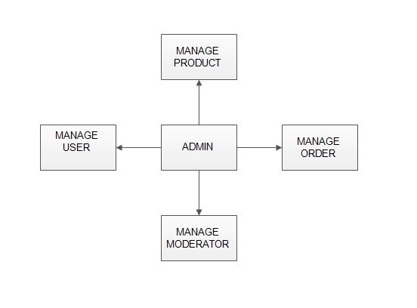

Figure: 1.1 ADMIN MODULE

1. **MANAGE PRODUCTS:**

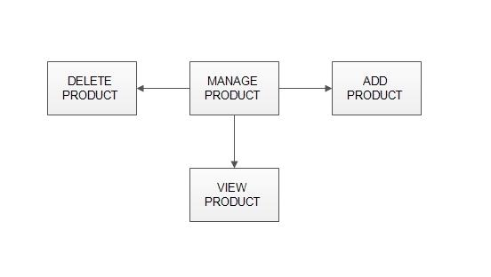

Figure: 1.2 Manage products

➢ **Add Products:**

The shopping cart project contains different kind of products. The products can be classified into different categories by name. Admin can add new products into the existing system with all its details including an image.

➢ **Delete Products:**

Administrator can delete the products based on the stock of that particular product.

➢ **Search products:**

Admin will have a list view of all the existing products. He can also search for a particular product by name.

1. **MANAGE USERS:**

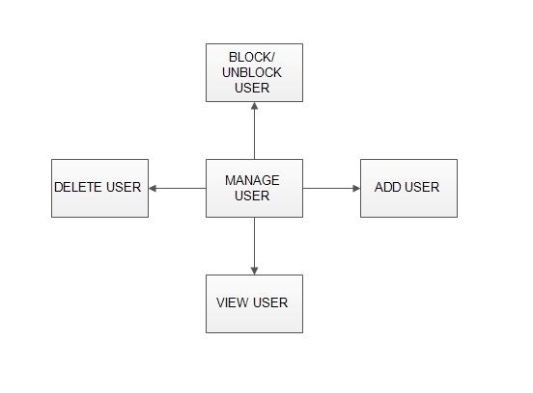

Figure: 1.3 Manage user

**View Users**

The admin will have a list view of all the users registered in the system. Admin can view all the details of each user in the list except password.

**Add Users**

Admin has privileges to add a user directly by providing the details.

**Delete &Block Users**

Administrator has a right to delete or block a user. The default status of a new user registered is set as blocked. The admin must accept the new user by unblocking him.

1. **MANAGE ORDERS:**

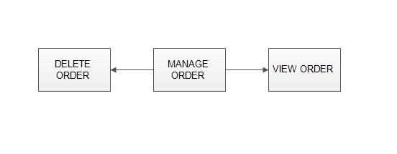

Figure: 1.4 Manage orders

**➢**

**View Order**

Administrator can view the Orders which is generated by the users. He can verify the details of the purchase.

**Delete order**

Admin can delete order from the orders list when the product is taken for delivery.

1.4.1.2 USERS:

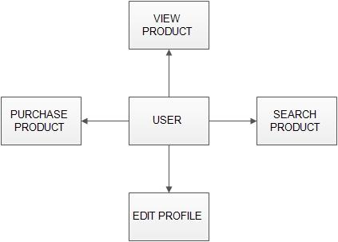

**➢**  Figure: 1.4 Users Module

**Registration**

A new user will have to register in the system by providing essential details in order to view the products in the system. The admin must accept a new user by unblocking him.

**➢ Login**

A user must login with his user name and password to the system after registration.

➢ **View Products**

User can view the list of products based on their names after successful login. A detailed description of a particular product with product name, products details, product image, and price can be viewed by users.

➢ **Search Product**

Users can search for a particular product in the list by name.

**➢ Add to cart:**

The user can add the desired product into his cart by clicking add to cart option on the product.

He can view his cart by clicking on the cart button. All products added by cart can be viewed in the cart. User can remove an item from the cart by clicking remove.

**➢ Submit Cart:**

After confirming the items in the cart the user can submit the cart by providing a delivery address. On successful submitting the cart will become empty.

**➢ History**

In the history the user will have a view of pending orders.

**➢ Edit Profile**

The user can view and edit the profile.

CHAPTER NO: 2

System Analysis

2.1 Software Requirement Specification

2.2 Process Model

* 1. Feasibility Study

**2.1 Software Requirement Specification**

**SRS for customize shopping**

This project is made for the customize shopping. This shopping site is made for the user requirements such as user choices, colours, material etc…

# 1. Functional requirements

# 2. Non-functional requirements

# FUNCTIONAL REQUIREMENTS

1. ***Allow user selection***

User can select any of the items as per their choice. The user select items such as watches, clothes, glasses as per their selection.

The user can select material they want from the website. They select by colour also.

1. ***Allow user choice for colour***

User can select items by the colours. The user requirement is also colour for that user choice colour is required.

The user can get many of the colours such as red, green, blue, yellow etc...

The user can choice the colour by their requirement they get the original product..

1. ***Different category maintenance***

For user the different category of shopping is maintained for user for their requirements...

1. *Customize clothes*

In this user can select the clothes such as t-shirts, paints etc…

For the t-shirts the user can select the colour of the t-shirt, size of the t-shirt, type of the t-shirts etc.

For the paints user select colour of the jeans, type of paints such as jeans, formal etc… design can be customize by the user.

1. *Customize watches*

The user can select watch as per their choice. The user can select belts, belts colour, dials colour, dials shape pendulum etc...

1. *Customize glasses*

The user can select glasses as per requirements. The user can select glasses frames colour, glasses frames, glasses number etc…

1. ***User can customize entire product***

If any product is ready, if user want to customize their product the user can customize that product…

E.g. If user had selected watch and at booking time if user want to change the belt of the watch the user can customize the entire product.

1. ***Purchase module***

The Purchasing of things is required as per user requirements …

The user can only purchase by a cash but by

1. CASH ON DELIVERY
2. ***Bill generation***

The bill generation is required for user.

In bill generation details are generated such as use name, date of purchasing product, money by cash by cash on delivery etc..

1. ***Administration module***

Through an administration module what user wants they will get products.

Through admin new products are shown to user.

Money can be set or reset by the admin.

Discount on which product are decided by the admin…

1. ***Login/log out***

The user login session is managed on visiting our shopping site.

The login details such as name, email, address, contact, state, city etc... Details are filled by the user side on login page. After user buy the product they will automatically log out from the website. If user want to buy anything after log out they want to login again into our website for the shopping.

1. ***State/session management***

State will be manage by our site. It means during login and logout time all the items of the user, his cart, its description will be store using session_id

. His session will be destroyed when user will logout from site.

1. ***Create your wish list***

The user select the product they want but it is not capable for user to buy that product so user can make a wish list of that product they want.

After some days or months user are capable to buy that product, the user gets easy to find that item they want.

**REQUIREMENT SPECIFICATION OF ADMIN**

1. Login.
2. Access Order.
3. Add and Delete items.
4. Access Feedback.
5. Access Payment.
6. Logout.

**REQUIREMENT SPECIFICATION OF USER**

1. Create New Account.
2. Give feedback.
3. Login.
4. Place Order.
5. Payment.
6. Logout.

Requirement of admin:-

1. ***Login***

* Description: The admin login into his\her account
* State: Here the user has been authenticated.
* Input: Admin username and password.
* Output: Admin will successfully login or Invalid Details.
* Process: Here the admin will be validated against the system’s database.

1. ***Access Order***

* Description: Here the admin can access order which user needs. The User will get that product according to their requirement.
* State: Here the user selects the option for an order.
* Input: Here admin can access the order according to the user requirement.
* Output: If the user requirement product is ok then successfully ordered or else discarded order.
* Process: Here the system will store data in data base and fetch webpage.

1. ***Add and Delete items***

* Description: Here the admin can add new items such as in clothes, glasses, watches, shoes or delete old items.
* State: admin has selected ADD or DELETE user accounts option.
* Input: product name, product specification.
* Output: Successful changes made by admin.
* Process: Changes made by admin will be saved permanently and stored in the database.

1. ***Access Feedback***

* Description: Here the admin can View and Delete Feedback.
* State: Here the admin has selected fill balance option.
* Input: Enter required details.
* Output: System will fetch webpage.

1. ***Logout***

* Description: The user will get log out after their task got over.
* State: admin choose logout option.
* Input: None.
* Output: Display website Homepage.
* Process: here various process will be done in the background from database.

Requirement of user or customer:-

1. Create New Account.

* Description: Here the user gets the login form.in that they want to fill details such as user name, birthdate, age, contact etc…
* State: Here the user has selected functionalities option.
* Input: Required Details.
* Output: Result will be displayed based on the condition.
* Process: Here the username will be checked against the current entries in Database and if the user already exists then it will show message that user already exists or invalid details else new user will be created and new entry is added in the Database.

1. Give Feedback

* Description: Here the user can give and read feedbacks about our web side.
* State: User has selected Feedback.
* Input: Required Details.
* Output: Feedback send successfully.
* Process: Inquiry sanded by user will be displayed in website.

1. Login

* Description: Here the user can login into his/her accounts.
* State: Here the user has been authenticated.
* Input: Admin username and password.
* Output: user will successfully login or Invalid Details.
* Process: Here the user will be validated against the system’s database.

1. Place Order

* Description: Here the user can place order as their requirement.
* State: here the user has selected Place Order option.
* Input: Here user will select product according to their specification and enter quantity of order.
* Output: Order placed successfully or Order invalid.
* Process: Here the system will fetch webpage.

1. MakePayment.

* Description: Here the user can make payments by CASH ON DELIVERY, ATM CARD payments.
* State: user has selected Make Payment option.
* Input: Enter Required Detail such as address, contact, payment by option etc...
* Output: Payment details will displayed.
* Process: Here the system will update database.

1. Logout

* Description: Here the user can save their modifications in their profile and logout.
* State: user choose logout option.
* Input: None.
* Output: Display website Homepage.
* Process: here various process will be done in the background from database.

# NON-FUNCTIONAL REQUIREMENTS

1. ***Software requirement***
2. Dream weaver

Dream weaver software is used as a coding part for project.it is used to design the project.

1. Xampp lite

XAMPP is used to provide server and provide the interconnection between server and client.

1. Mozilla /Google chrome

Mozilla Firefox and Google chrome are user for client side for an output which is processed by server.

1. Photoshop

Photoshop is used for the designing, styling, colours, editing the photos and provides user requirement.

1. ***Hardware requirement***

|  |  |
| --- | --- |
| RAM | 2 GB |
| HARD DISK | 250 GB |
| PROCESSOR | DUAL PROCESSOR |

**2.2 Process Model**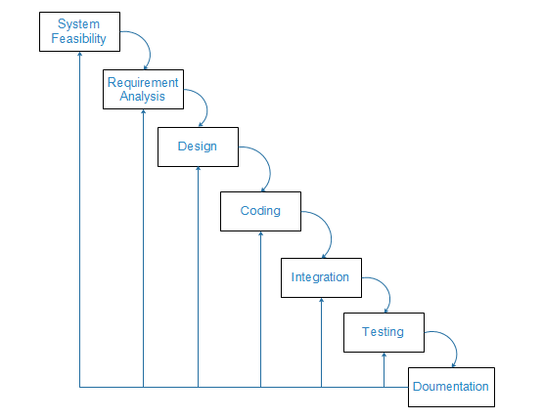

**Why we use this model?**

We use iterative model because every step is repeated so we can easily implement all new changes.

By working iteratively, the project team goes through a cycle where they evaluate with each iteration, and determine what changes are needed to produce a satisfactory end product.

In iterative model we can only create a high-level design of the application before we actually begin to build the product and define the design solution for the entire product. Later on we can design and built a skeleton version of that, and then evolved the design based on what had been built.

**2.3 Feasibility Study**

**FEASIBILITY STUDY**

Feasibility Analysis is whether a project is operational in practice. The task of

Feasibility analysis is to analyse the problem to be addressed in the technical,

Economic, legal, use of viability. And the purpose of the project is the use of least

Cost in the shortest possible time to determine the problem definition stage of the

Envisaged system described by the basic objectives and whether the scale can be

Solved, or the possibility of solving the value of the size and address size. Its essence is to maximize the compression system analysis, system design, and a high level in a more abstract way in a system analysis, system design.

Generally speaking, feasibility analysis is studied from the following three aspects:

**1)** **Economic feasibility.** The project is economically feasible as the only cost involved is having a computer with the minimum requirements mentioned earlier. For the users to access the application, the only cost involved will be in getting access to the Internet.

**2)** **Technical feasibility**. Technical feasibility from the technical point of view

is based on the system functionality, performance and a variety of constraints required by user to achieve the feasibility of the system. It Is often the most difficult during developing the system.

To deploy the application, the only technical aspects needed are mentioned below:

Operating Environment Win 2000/XP Platform .Net Framework & IIS Database SQL Server 2005

**For Users:**

Internet Browser

Internet Connection

**3)** **Operational feasibility**. Operational feasibility is whether the design is

suitable for the user organizations, and whether the management, personnel

and operation are applicable.

The application requires no special technical guidance and all the views available

in the application are self explanatory. The users are well guided with warning and failure messages for all the actions taken.

* **Technical feasibility**

The system is developed using PHP , ASP and SQL Server 2000, not other professional technology.

PHP is a server side scripting Language this means that the script code is processed on the web server rather than on client side .only processed output is presented to the client in html format. To make sure this run the above code in browser like Google chrome and then right click and choose view source option and observe that no php code is displayed only processed output is displayed.

ASP (Active Server Pages) is provided by Microsoft, which is a server-side

script-based Web development tools and runtime environment. It can be used to

create and run dynamic interactive Web application program. As we know, ASP

and browser are separate, and the interpretation the implementation of ASP is in the

server side. So there is no need to consider browser-based ASP support and worry

about programming logic to be stolen by downloading program.

SQL Server 2000 is a scalable relational database, based on the Structured Query

Language (SQL). It can support Internet applications Extensible Markup Language– XML. Its components are databases, relational databases, extensible markup

language and structured query language. It has increasingly become one of ideal

development tool for database application under the platform of Windows system

because of its good performance. It can meet the enterprise’s data processing system and Website data storage and analysis needs through mutual cooperation a series of constituent components.

B/S (Browser / Server) Is a client technology. The Technology platform is very stable and it is suitable for medium and large enterprises. Hundreds of millions of users who wish to enjoy the rich information service can just through the browser interface.

Therefore, the requirement for technology developers is to master the basic ASP, SQL Server 2000, B / S Mode and related skills on the basis of the hardware and its functions.

* **Operational feasibility**

1) Requirements for system administrators: Have some computer expertise,

and a training of system.

2) Requirements for the user's: Have the Internet and basic computer operations.

In the legal feasibility part, all software used is genuine.

* **Conclusion**

As the Income more than investment, and the technical, economic, operational, Legal feasibility are available, the system can be developed.

CHAPTER NO: 3

System Design

3.1 E-R Diagram

3.1.1 Complete E-R diagram

3.2 Data Flow diagram

3.2.1 LOGIN DFD

3.2.2 REGISTRATION DFD:

3.2.3 ADMIN DFD:

3.2.4 USER DFD

* 1. Use Case diagram

3.3.1 ADMIN USECASE DIAGRAM

3.3.2 USER USECASE DIAGRAM

3.4 Activity diagram

3.4.1 ADMIN USECASE DIAGRAM

3.4.2 USER USECASE DIAGRAM

**3.1 E-R Diagram**

3.1.1 COMPLETE ER DIAGRAM:

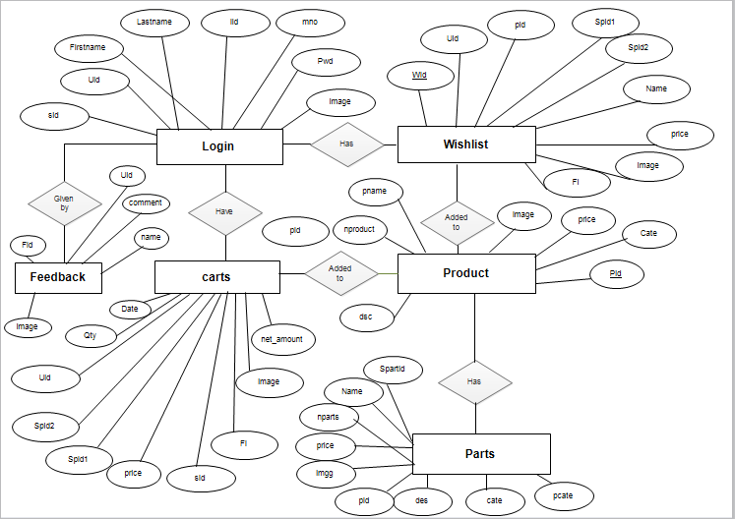

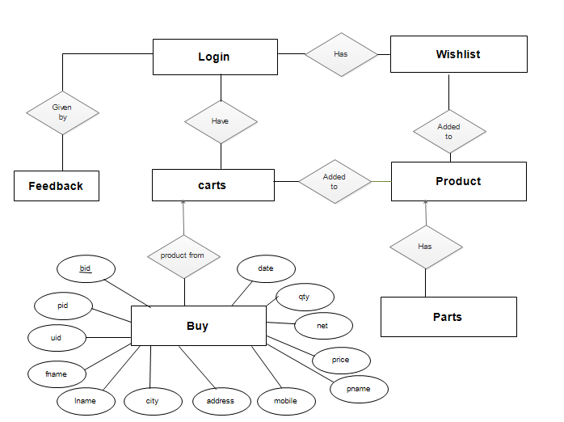

Figure: 3.1 Complete E-R Diagram

**3.2 Data Flow Diagram**

A Data Flow Diagram (DFD) is a structured analysis and design tool that can be used for flowcharting. A DFD is a network that describes the flow of data and the processes that change or transform the data throughout a system. This network is constructed by using a set of symbols that do not imply any physical implementation. It has the purpose of clarifying system requirements and identifying major transformations. So it is the starting point of the design phase that functionally decomposes the requirements specifications down to the lowest level of detail. DFD can be considered to an abstraction of the logic of an information-oriented or a process-oriented system flow-chart. For these reasons DFD’s are often referred to as logical data flow diagrams.

EXTERNAL ENTITY

An external entity is a source or destination of a data flow. Only those entities which originate or receive data are represented on a data flow diagram. The symbol used is a rectangular box.

PROCESS

A process shows a transformation or manipulation of data flow within the system. The symbol used is an oval shape.

DATAFLOW

The data flow shows the flow of information from a source to its destination. Data flow is represented by a line, with arrowheads showing the direction of flow. Information always flows to or from a process and may be written, verbal or electronic. Each data flow may be referenced by the processes or data stores at its head and tail, or by a description of its contents.

DATA STORE

A data store is a holding place for information within the system: It is represented by an open ended narrow rectangle. Data stores may belong-term files such as ledgers, or may be short-term accumulations: for example batches of documents that are waiting to be processed. Each data store should be given a reference followed by an arbitrary number.

3.2.1 LOGIN DFD

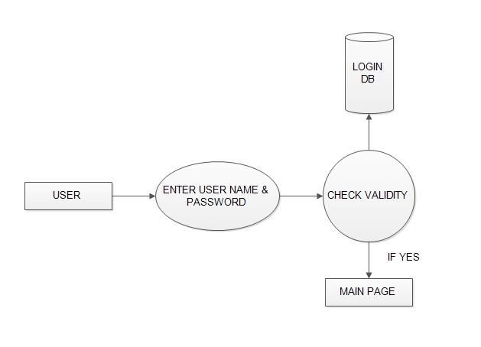

Figure: 3.2 Login DFD

3.2.2 REGISTRATION DFD:

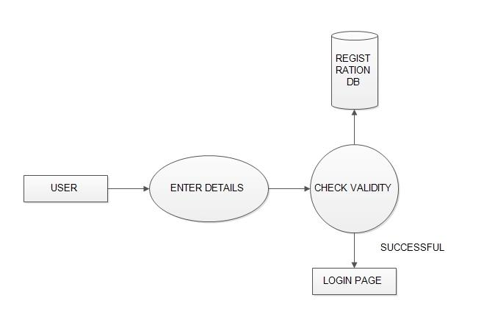

Figure: 3.3 Registration DFD

3.2.3 ADMIN DFD:

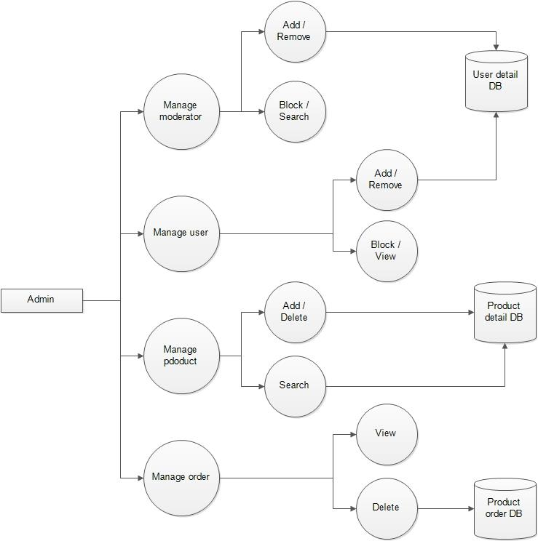

Figure: 3.4 Admin DFD

3.2.4 USER DFD

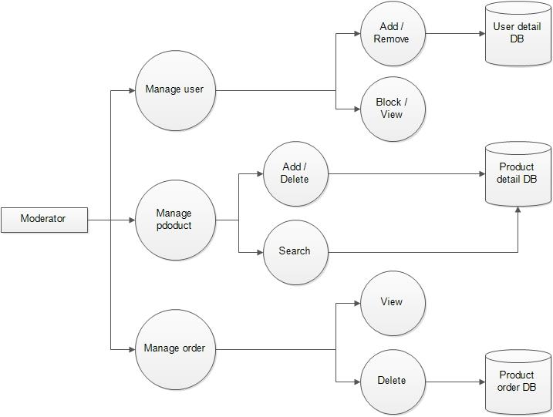

Figure: 3.5 USER DFD

**3.3 Use-Case Diagram**

3.3.1 ADMIN USECASE DIAGRAM:

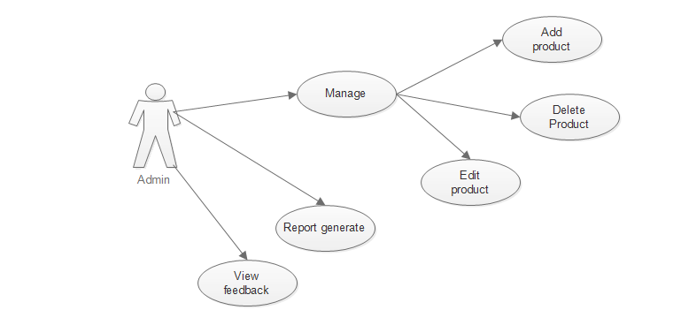

Figure: 3.6 Admin USECASE Diagram

3.3.2 USER USECASE DIAGRAM:

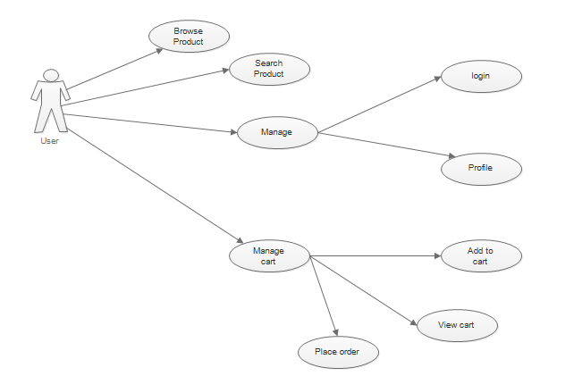

Figure: 3.7 User USECASE Diagram

**3.4 Activity Diagram**

3.4.1 ADMIN ACTIVITY DIAGRAM:

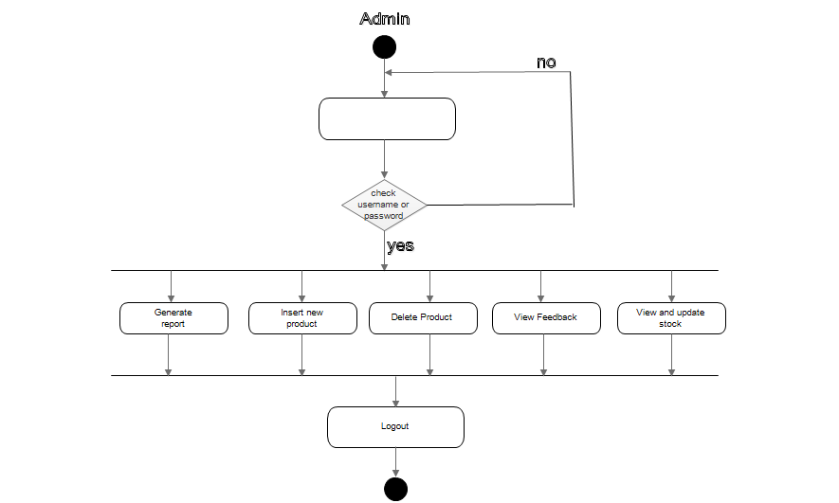

Figure: 3.8 Admin Activity Diagram

3.4.2 USER ACTIVITY DIAGRAM:

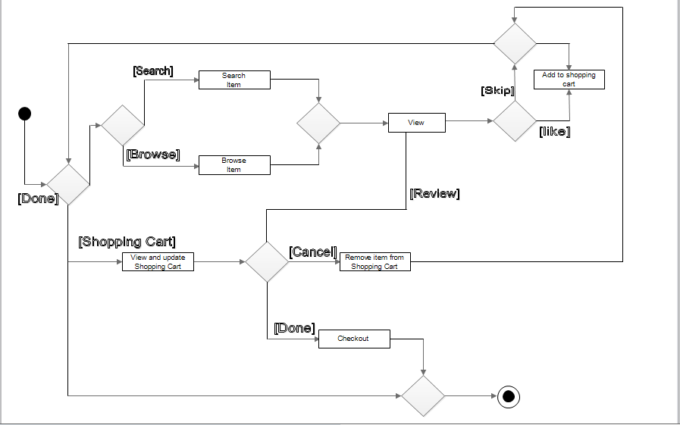

Figure: 3.9 User Activity Diagram

CHAPTER NO: 4

Data Dictionary

4.1 Database Tables

**4.1 Database Tables**

**Login:**

|  |  |  |  |  |
| --- | --- | --- | --- | --- |
| Field | Data type | Size | Constrains | Description |
| Lid | Int | 20 | Primary | It holds the login id |
| Firstname | Varchar | 50 | Not null | It holds the user Firstname |
| Lastname | Varchar | 30 | Not null | It holds the user Lastname |
| Mno | bigint | 10 | Not null | It holds the mobile number |
| Uid | Varchar | 30 | Not null | It holds the user Id |
| Pwd | Varchar | 50 | Not null | It holds the Password |
| Sid | Varchar | 40 | Not null | It holds the  Sub id |
| Image | Varchar | 30 | Not null | It holds the image |
| Promocode | Varchar | 4 | Not null | It holds the promo code |
| Usep | Int | 2 | Not null | It holds the user product |

**Product:**

|  |  |  |  |  |
| --- | --- | --- | --- | --- |
| Field | Data type | Size | Constrains | Description |
| Pid | int | 15 | Primary | It holds the pid |
| Pname | varchar | 30 | Not null | It holds the pname |
| Dsc | Varchar | 70 | Not null | It holds the Description |
| Nproducts | int | 40 | Not null | It holds the nproducts |
| Image1 | Varchar | 100 | Not null | It holds the image |
| Price | int | 20 | Not null | It holds the price of product |
| Cate | Int | 30 | Not null | It holds the category of the project |

**Possibility:**

|  |  |  |  |  |
| --- | --- | --- | --- | --- |
| Field | Data type | Size | Constrains | Description |
| Possid | Int | 10 | primary | It holds the position id |
| Pid | Int | 10 | Not null | It holds the product id |
| Spartid1 | Int | 10 | Not null | It holds the sub part id-1 |
| Spartid2 | Int | 10 | Not null | It holds the sub part id-2 |
| Image | Varchar | 50 | Not null | It holds the image |

**Parts:**

|  |  |  |  |  |
| --- | --- | --- | --- | --- |
| Field | Data type | Size | Constrains | Description |
| Spartid | Int | 10 | Primary | It holds the sub part id |
| Pid | Int | 10 | Not null | It holds the product Id |
| Des | Varchar | 500 | Not null | It holds the description |
| Imgg | Varchar | 100 | Not null | It holds the image |
| Price | Int | 10 | Not null | It holds the price of the part |
| Cate | Varchar | 10 | Not null | It holds the Category of parts |
| Pcate | Int | 10 | Not null | It holds the  Product category |
| Nparts | Varchar | 30 | Not null | It holds the number of parts |
| Name | varchar | 100 | Not null It holds the user product | It holds the name of parts |

**Feedback:**

|  |  |  |  |  |
| --- | --- | --- | --- | --- |
| Field | Data type | Size | Constrains | Remarks |
| Fid | Int | 10 | primary | It holds the feedback id |
| Uid | Varchar | 40 | Not null | It holds the user id |
| Comment | Varchar | 100 | Not null | It holds the comment of the user |
| Name | Varchar | 30 | Not null | It holds the name of the user |
| Image | Varchar | 30 | Not null | It holds the image of the user |

**Buy:**

|  |  |  |  |  |
| --- | --- | --- | --- | --- |
| Field | Data type | Size | Constrains | Description |
| Bid | Int | 11 | Primary | It holds the buyer id |
| Pid | Int | 11 | Not null | It holds the user product id |
| Uid | Varchar | 30 | Not null | It holds the user user id |
| Fname | varchar | 30 | Not null | It holds the first name of user |
| Lname | Varchar | 30 | Not null | It holds the last name of user |
| Pwd | Varchar | 50 | Not null | It holds the Password |
| City | Varchar | 30 | Not null | It holds the  Name of the city |
| Address | Varchar | 500 | Not null | It holds the Address of the user |
| Mobile | bigint | 12 | Not null | It holds the mobile number user |
| Pname | varchar | 30 | Not null | It holds the product name |
| Price | Int | 10 | Not null | It holds the price of the product |
| Net | Int | 10 | Not null | It holds the total amount |
| Qty | Int | 10 | Not null | It holds the quantity |
| Date | date |  |  | It holds the date |

**Cart:**

|  |  |  |  |  |
| --- | --- | --- | --- | --- |
| Field | Data type | Size | Constrains | Description |
| Cartid | Int | 40 | Primary | It holds the Cart id |
| Uid | Varchar | 40 | Not null | It holds the user Id |
| Pid | Int | 40 | Not null | It holds the product id |
| Date | date |  | Not null | It holds the date |
| Sid | Varchar | 40 | Not null | It holds the session id for user |
| Qty | Int | 40 | Not null | It holds the quantity of product |
| price | Int | 50 | Not null | It holds the price of product |
| Net_amount | Int | 50 | Not null | It holds the amount of product |
| Spid1 | Int | 10 | Not null | It holds the sub part id of product-1 |
| Spid2 | Int | 10 | Not null | It holds the sub part id to the user-2 |
| image | varchar | 30 | Not null | It holds the image of prduct |
| Fi | Int | 30 | Not null | It holds the folder id |

**Wishlist:**

|  |  |  |  |  |
| --- | --- | --- | --- | --- |
| Field | Data type | Size | Constrains | Description |
| Wid | Int | 40 | Primary | It holds the wishlist id |
| Uid | Varchar | 40 | Not null | It holds the user id |
| Pid | Int | 40 | Not null | It holds the product id |
| Spid1 | Int | 10 | Not null | It holds the sub part id 1 |
| Spid2 | Int | 10 | Not null | It holds the sub part id 2 |
| name | Varchar | 30 | Not null | It holds the name of product |
| price | Int | 30 | Not null | It holds the  Price of product |
| Image | Varchar | 30 | Not null | It holds the image of product |
| Fi | Int | 10 | Not null | It holds the folder id of product |

CHAPTER NO: 5

Input, Output and design

5.1 Screen Shots of User Panel

**5.1 Screen Shots of User Panel**

* LOGIN

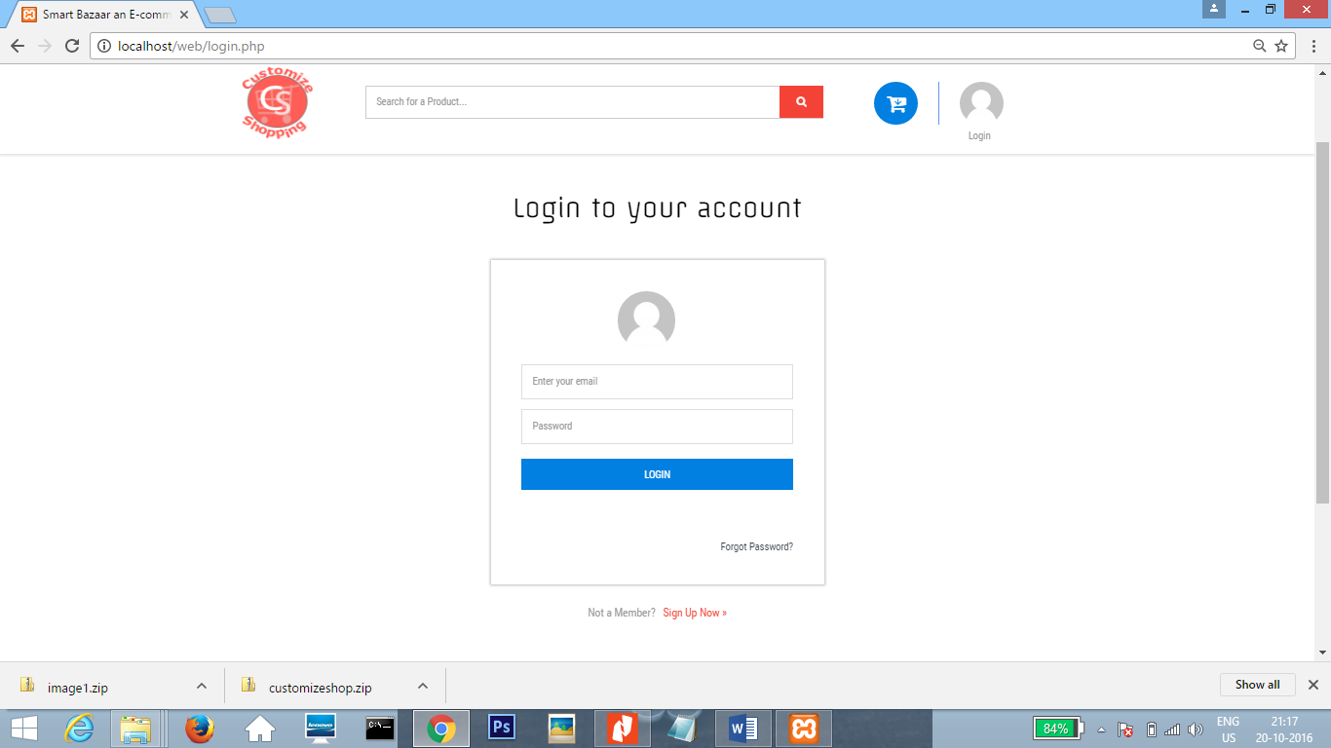

Screenshot-1: Login Page

* SIGNUP

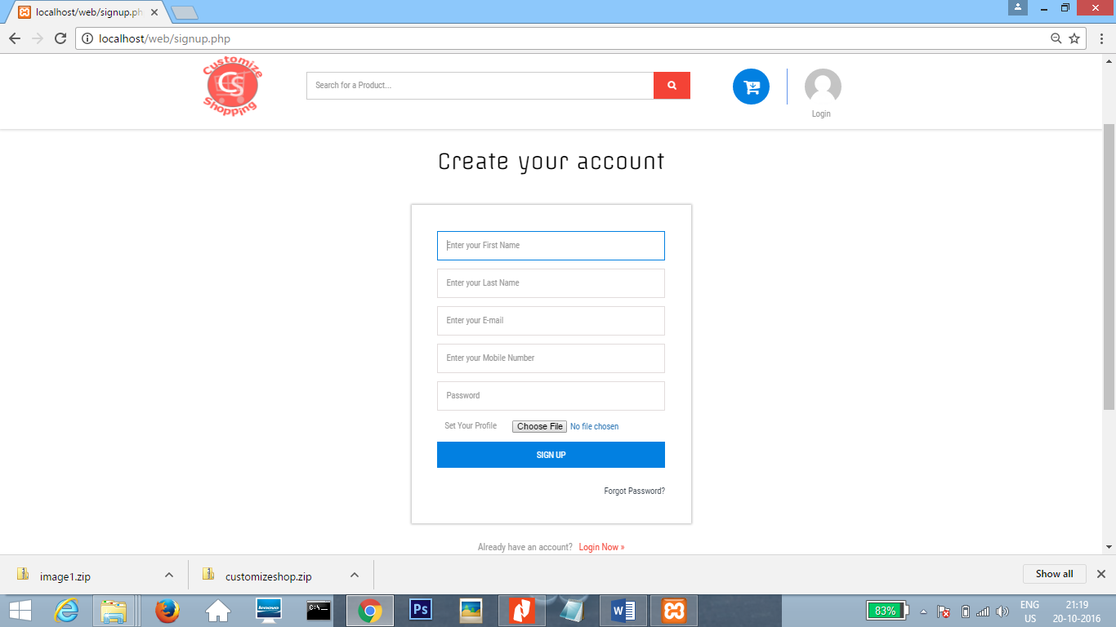

Screenshot-2: Signup Page

* HOME

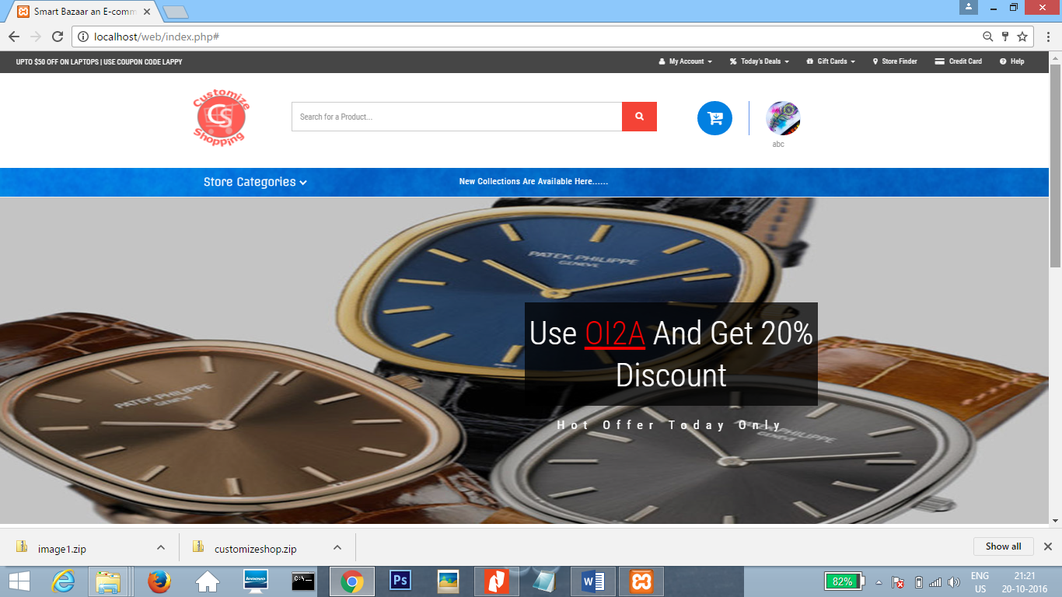

Screenshot-3: Home Page 1

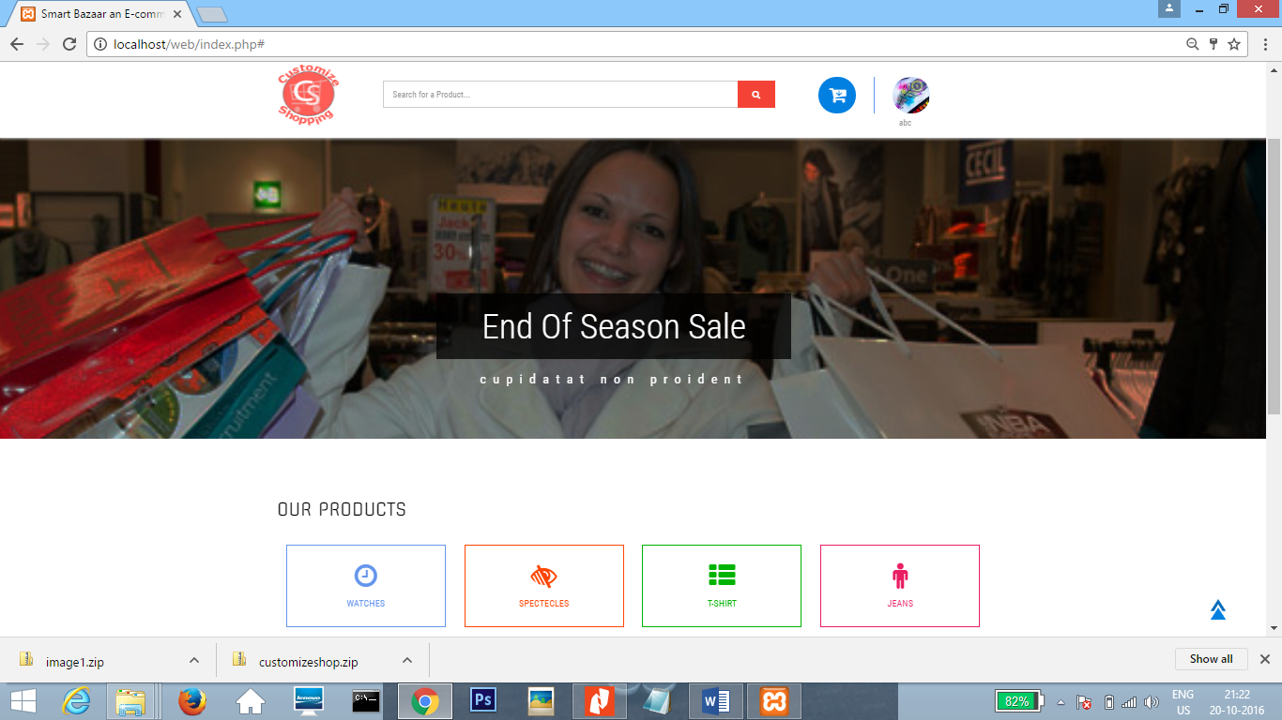

Screenshot-4: Home Page 2

* Product

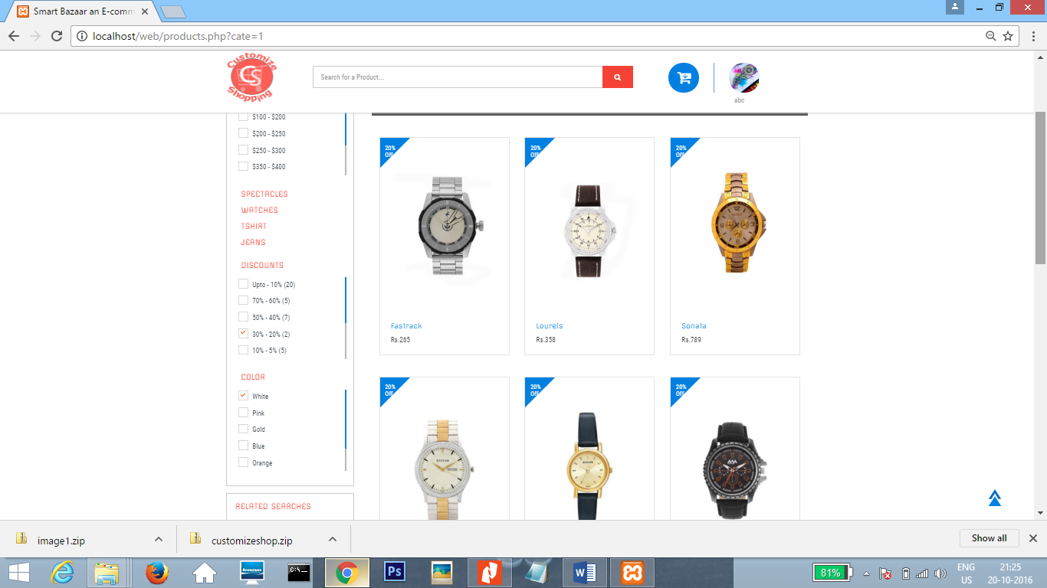

Screenshot-5: Product Page

* ADD TO CART

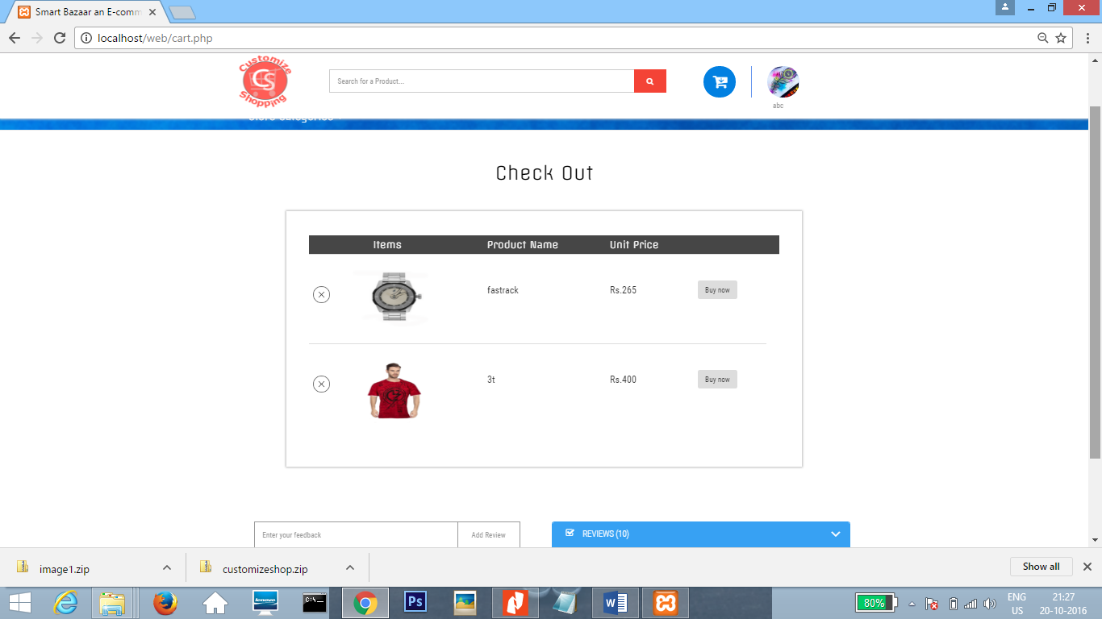

Screenshot-6: Add to Cart Page

* BILL SYSTEM

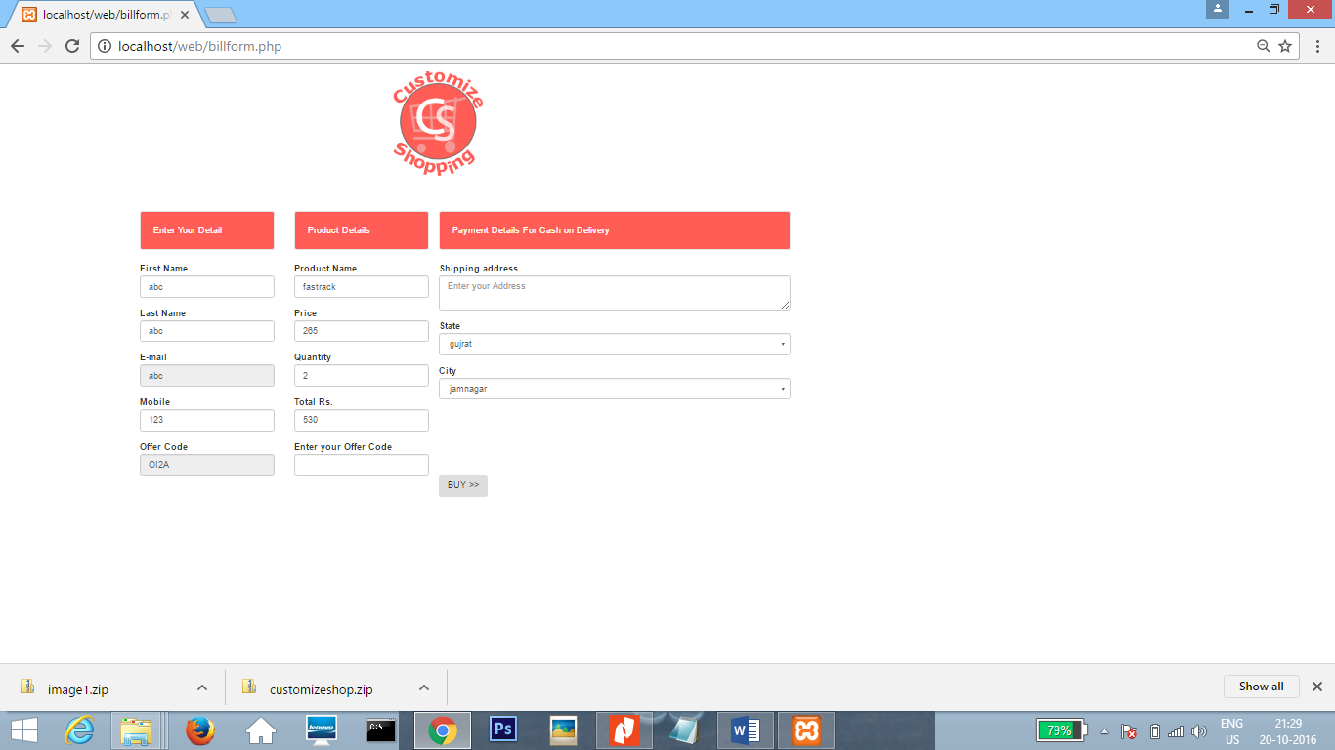

Screenshot-7: Bill System Page

* BILL

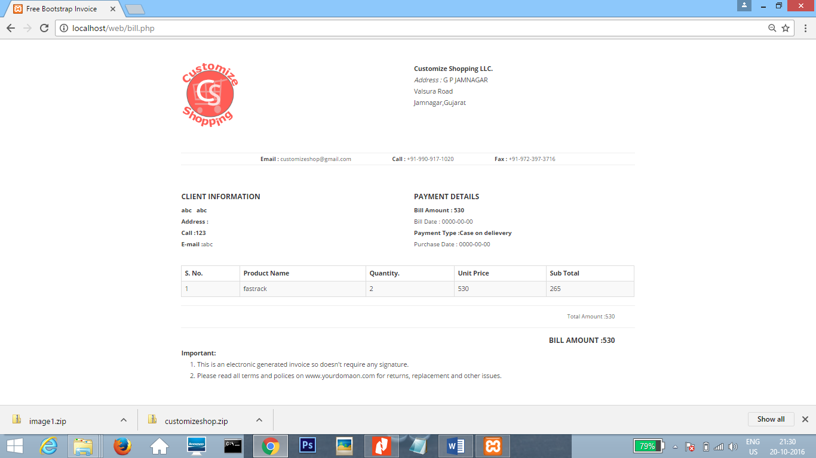

Screenshot-8: Bill Page

CHAPTER NO: 6

TESTING PRINCIPLES AND METHOD

6.1 Testing Cases Report

**6.1 Testing Cases Report**

|  |  |
| --- | --- |
| Test Case:1(Admin) | |
| Test to be performed | Login of admin |
| Expected Result | Successfully logged-in |
| Actual Result | Successfully Logged in |
| Result | PASS |
| Type of Test | Module Test |

|  |  |
| --- | --- |
| Test Case:2(Admin) | |
| Test to be performed | To verify that when admin will click on Block, user should be blocked, effect should be reflected in database as well as on the screen |
| Expected Result | User should be blocked in to database and should not be able to login in to the website. |
| Actual Result | User is blocked from database and also not be able to login to the system. |
| Result | PASS |
| Type of Test | Module Test |

|  |  |
| --- | --- |
| Test Case:3(Admin) | |
| Test to be performed | To verify that when admin will click on add Product button to add new product for discussion should be reflected on database as well as on the screen |
| Expected Result | Product should be added, it should be added on the screen. |
| Actual Result | New Product is added into the database as well as on the screen. |
| Result | PASS |
| Type of Test | Module Test |

|  |  |
| --- | --- |
| Test Case:4(User) | |
| Test to be performed | The login system must work properly and user email and password must be checked from database. |
| Expected Result | While checking specific error message should be displayed to user if the result does not match. |
| Actual Result | User will be provided with specific error message. |
| Result | PASS |
| Type of Test | Module Test |

|  |  |
| --- | --- |
| Test Case:5(User) | |
| Test to be performed | Validation of every input on the registration page. |
| Expected Result | Do not register if input type does not match. |
| Actual Result | Can’t register if user has filled wrong input data. |
| Result | PASS |
| Type of Test | Module Test |

|  |  |
| --- | --- |
| Test Case:6(User) | |
| Test to be performed | To verify that when user will search for Product in search box related Product should be displayed. |
| Expected Result | Related Product should be display in the search box. |
| Actual Result | Related Product will be display. |
| Result | PASS |
| Type of Test | Module Test |

|  |  |
| --- | --- |
| Test Case:7(User) | |
| Test to be performed | To verify that when user will click on Add to Cart in the product and click on “buy” button the Bill System should be Displayed. |
| Expected Result | Bill Page Should be Displayed. |
| Actual Result | Bill Page will be Displayed. |
| Result | PASS |
| Type of Test | Module test. |

|  |  |
| --- | --- |
| Test Case:8(User) | |
| Test to be performed | To verify that when user will click on “Add review” the particular comment should be added to the Comment Box. |
| Expected Result | The comment should be added to the Reviews. |
| Actual Result | The comment will be added to the Reviews. |
| Result | PASS |
| Type of Test | Module Test |

|  |  |
| --- | --- |
| Test Case:9(User) | |
| Test to be performed | To verify that when user will enter feedback in the description box and click to send button the particular feedback should be display on the screen. |
| Expected Result | The comment should be displayed on the screen. |
| Actual Result | The comment will be displayed on the screen. |
| Result | PASS |
| Type of Test | Module Test |

|  |  |
| --- | --- |
| Test Case:10(User) | |
| Test to be performed | To verify that when user will click on log- out button user must be sign out and session must be destroyed. |
| Expected Result | User should be signed-out and session must be destroyed. |
| Actual Result | User is signed-out and only can enter in to the system after log-in. |
| Result | PASS |
| Type of Test | Module Test |

CHAPTER NO: 7

Timeline Chart (Gannt chart)

7.1 Timeline chart

**6.1 Timeline chart**

|  |
| --- |
| 30-06-2016 To 17-10-2016 |

|  |  |  |  |  |  |  |  |
| --- | --- | --- | --- | --- | --- | --- | --- |
| **Development**  **Phase** | **110 Days** | | | | | | **Duration**  **(Days)** |
| **1 to 15**  **Days** | **16 to 33**  **Days** | **34 to 50**  **Days** | **51 to 75**  **Days** | **76 to 90**  **Days** | **91 to 110**  **Days** |
| **Requirements**  **Gathering** |  |  |  |  |  |  | **1-15**  **(15Days)** |
| **Analysis** |  |  |  |  |  |  | **16-33**  **(18days)** |
| **Design** |  |  |  |  |  |  | **34-50**  **(17days)** |
| **Coding** |  |  |  |  |  |  | **51-75**  **(25days)** |
| **Testing** |  |  |  |  |  |  | **76-90**  **(15days)** |
| **Implementation &**  **Deployment** |  |  |  |  |  |  | **91-110**  **(15days)** |
| **Total Time (Days)** |  | | | | | | **110 Days** |

CHAPTER NO: 8

Conclusion

8.1 Conclusion

**8.1 Conclusion**

The project entitled **Customize shopping** was completed successfully.

The system has been developed with much care and free of errors and at the same time it is efficient and less time consuming. The purpose of this project was to develop a web application and an android application for purchasing items from a shop.

This project helped us in gaining valuable information and practical knowledge on several topics like designing web pages using html & css, usage of responsive templates, designing of android applications, and management of database using mysql . The entire system is secured. Also the project helped us understanding about the development phases of a project and software development life cycle. We learned how to test different features of a project. Project has given us great satisfaction in having designed an application which can be implemented to any nearby shops or branded shops selling various kinds of products by simple modifications.

There is a scope for further development in our project to a great extent. A number of features can be added to this system in future like providing moderator more control over products so that each moderator can maintain their own products. Another feature we wished to implement was providing classes for customers so that different offers can be given to each class. System may keep track of history of purchases of each customer and provide suggestions based on their history. These features could have implemented unless the time did not limited us.

CHAPTER NO: 9

References

9.1 References

**9.1 Reference**

* PHP and My SQL Web Development by Luke Willing
* My SQL Bible Book
* Beginning PHP5
* Professional PHP5
* Advance PHP Programming by George Schlossnagl.